The NOVEMBER Leaven 2021

THE CHURCH COMMITTEE - A GOOD PLACE TO GET INVOLVED!

It is the Session, of course, that is ultimately responsible for governing the church with guidance and input from the pastor, but the Session relies heavily on the various committees that function under it in carrying out its obligations to the members of the congregation.

Currently the church maintains 10 committees, all but one of which are headed by one or more members of the Session. These committees are the Worship Committee, the Mission Committee, the Christian Education Committee, the Building & Grounds Committee, the Communications Committee, the Faithful Discipleship Committee, the Administration/Personnel Committee, the Endowments, Memorials and Scholarships Committee, the Nominating Committee, which is made up of two Elders, one Deacon and four members of the congregation at large, and the Renovations/Capital Campaign Committee, which is the non-Session committee.

Some of these committees meet regularly and on a certain Sunday of the month after church, while others may meet of an evening or less frequently, depending on the time of year and whether or not there is any pressing business that needs to be addressed. But with the exception of the Nominating Committee, I think I can say with a fair degree of certainty that all of these committees are open to adding new members, especially if these new members are truly interested in helping with the work of the committee.

The committee I chair, the Faithful Discipleship Committee, may well be the only one of the entire bunch where, based on the name of the committee, one might not be sure what exactly it is that the committee deals with. Well, my committee is charged with the task of promoting and carrying out the four denominational offerings of the Presbyterian Church (USA), and it also organizes the annual stewardship campaign here at First Presbyterian Church, promoting the giving of one's time, talents and treasures to the church through what we call Faithful Discipleship testimonies.

If you have any questions about the role any of these committees play in the life of the church, please feel free to get in touch with me and I will do my best to give you a satisfactory answer. More important, this being the month for Stewardship Sunday, as we all look ahead to 2022 and to what we hope to accomplish then, I hope you will prayerfully consider becoming more involved in the work of the church next year by joining one or more of these committees. Your input will be welcome and, quite frankly, your active participation in the work of the church is needed.

Of course, serving on either the Session or the Board of Deacons for a three-year term is always an option for you to consider. If either possibility appeals to you, I would encourage you to contact Session members Ann Keeling or Debbie Anderson, the co-moderators of the Nominating Committee.

Rick Nichols, Clerk of Session

THIRTY DAYS OF THANKSGIVING

Two years ago, the Mission Committee launched a new program aimed at collecting food for the needy during the holiday season. The idea was to place one food item each day in blue bags that were furnished by the church, and, at the end of a month, deliver the filled bags to the Leavenworth Mission on Spruce Street. Above is a photo of that first year’s drive.
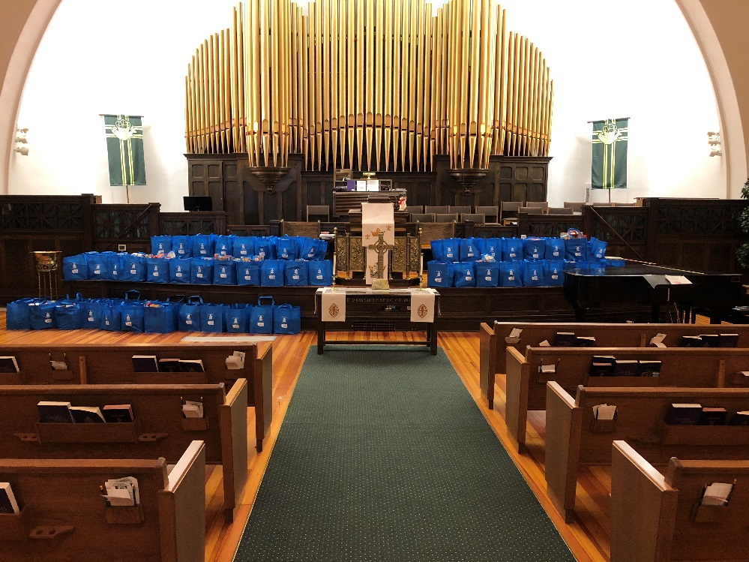
This year we started the collection earlier so that the Mission will have the food in time for Thanksgiving. If you have not yet done so, pick up your two bags and your list from the church, do your shopping, and bring your filled bags to the church by Sunday, November 14.

Let’s out do last year’s collection!

COMMUNITY MEAL
In October 140 community meals were served. Thanks to Howard Kirk going to the park to give guests a hot meal.
PWC
OPERATION CHRISTMAS CHILD

It is also the time we began thinking about Operation Christmas Child as we have one month left to get our boxes together. Presbyterian Women have been supporting this Mission for Children across the world for many years. Operation Christmas Child (OCC) is a division of Samaritan’s Purse.
This year the boxes are due to the Church by the first week in November so that we may get them to the local distribution point. Help lists, colorful shoeboxes, and labels are available in the Narthex. (You may use your own cardboard or plastic shoeboxes.) Each box should be packed for a girl or a boy in age category 2-4; 5-9; 10-14. The box may be a child’s only gift – include fun things as well as school and hygiene items. (Ideas are on the help sheet).
Donations toward the $9/box shipping costs are welcome (checks should be made out to Samaritan’s Purse or, if giving via our church, indicate OCC in the payment line with your cash/check.) If you give your donation on line you may track your box (you will receive a special tracking label). For a lot of good information go to https://www.samaritanspurse.org/what-we-do/operation-christmas-child/
Let's make this our most generous year yet!

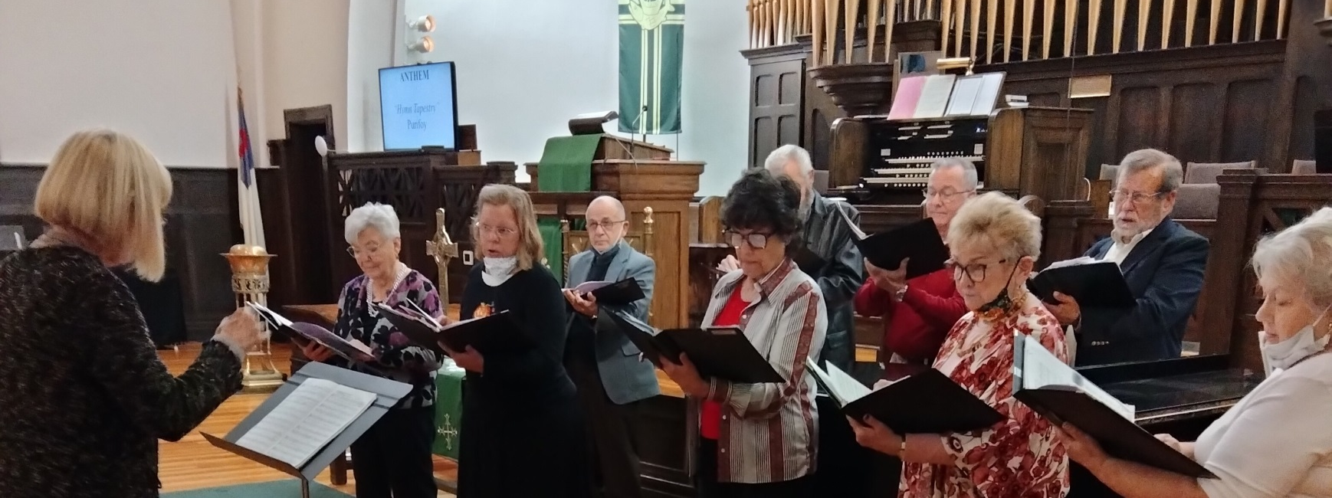

HALLOWEEN TREAT
Our choir led by Music Director Freda Proctor performed during the Sunday, October 31 service, marking the fourth time in as many Sundays that it had sung an anthem since it went silent in March 2020 because of the coronavirus pandemic. Welcome back, choir!

TRUNK AND TREAT
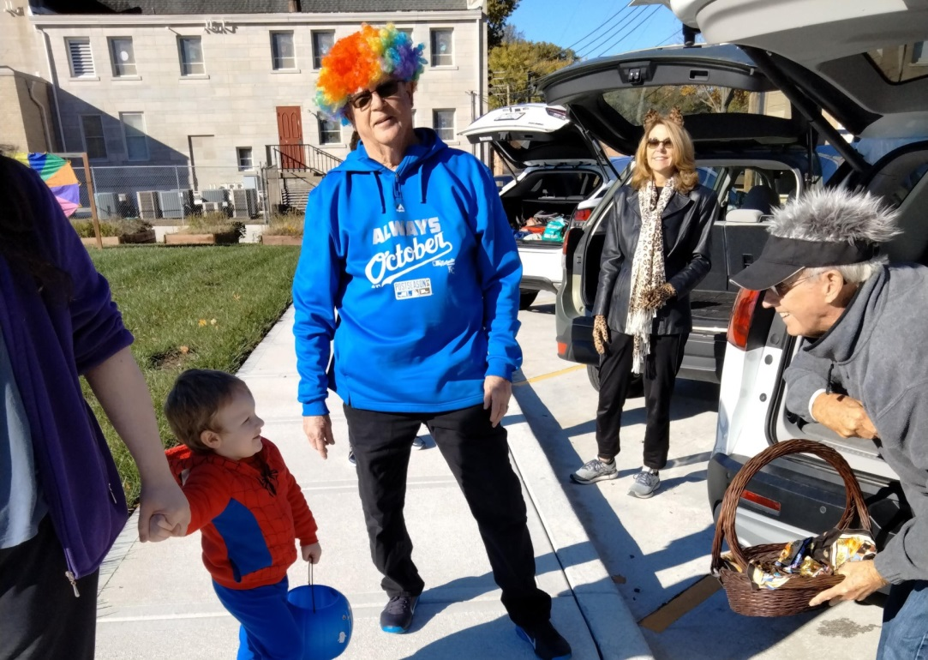
As Claude Wiedower and Debbie Anderson look on, Jim Roe waits to hand out some candy during the Fall Festival Saturday, October 30 that was hosted by our neighbors just to the south of us at the First United Methodist Church. Other participants included Patricia Domann, Merna Roe, Ann Keeling and Carolyn Tillotson.

THE ONLY THINGS I CHOOSE TO REMEMBER ARE THAT MEAL AND THAT HUG

On the afternoon of Sunday, October 3, as I was in Olathe getting ready for a special meeting of the Session via Zoom, the fellow who lives immediately to the south of my old house in Leavenworth called to tell me that the lady who lived in the house immediately to the north of me was dead.

I was stunned. Sandy (not her real first name) had lived in that house since 2004, and based on a conversation I had had with her a number of years ago, I think she was about 55 but certainly no more than 60. Turns out a concerned co-worker and the cops entered her house the same day I had surgery, September 28, and found her deceased on the bed. They think she had suffered a heart attack three days earlier, and according to my neighbor, a search of her cell phone activity indicated that she had been looking on the Internet for information pertaining to heart health. Yes, she was a little overweight given her height, five feet and change, I'd say, but she was definitely not obese.

Like many people these days, Sandy had held more than one job during the course of her working years, and she often worked odd hours, including some weekend time, at the jobs she held down. She also had a soft spot in her heart for animals and several of them made their home with her there in that modest, unpretentious house along South Esplanade Street.

I happened to have a face-to-face conversation with another one of my neighbors a week or so after I had learned of Sandy's death, and he proceeded to inform me that she had begun drinking more following the death of her longtime four-legged companion, her dog Riffraff (likely a shelter animal), and that the company she worked for had been thinking about firing her if she couldn't get her drinking under control. He also suggested that she had a gambling problem and said something about her having two mortgages on the house.

I don't know how much, if any, of what this neighbor told me is true, but I suspect that he was right about that double mortgage. All I know is that I never encountered Sandy in a drunken state and I never heard her talk about playing the lottery or going to the boats. As far as I was concerned, she was a halfway decent person who never caused me any problems but who would have benefited from an occasional Sunday in church (and she knew where I went to church and had been invited to attend on more than one occasion).

I met Sandy's parents the summer of 2004 when she had me over for dinner one night, but both of them are gone now. Her father died several years ago and her mother passed away a year or so ago. She had been living in Denver, which is where Sandy's brother was living at the time. But all these years later I still remember that wonderful evening when my modest, unpretentious neighbor was kind enough to share a meal with me in the company of her parents, who seemed to be real down to earth ordinary people.

More recently, Sandy gave me a big hug when I really needed one. The occasion was three years ago in November after I had had my mini stroke, this the result of high blood pressure combined with worries over the Leavenworth house and the Olathe house where my mother has lived since the early 1950s. I had gotten out of my car (she was preparing to enter hers) and was standing near the back end of it looking very lost, very alone and very scared of what the future seemed to hold in store for me when she readily perceived that I was not doing well either mentally or emotionally and then said to me, "Come here. I want to give you a hug."

And so she did right there in broad daylight and without a second thought as to what anyone might think ... and now she's gone.

Rick Nichols

FELLOWSHIP TREATS
Nov. 7-Deacons Nov. 14 –Session Nov. 21-Choir and Bell Choir Nov. 28-Circle 3

NOVEMBER BIRTHDAYS
1- Twila Corley 3- Tera Cameron 7- George Morton 10-Jim Williams 10- Kathy Kenton
13- Ginnie Strand 17- Brent Gummert 18- Alexa Allen 18- Emalee Litewski 22- Elaine Carder
25-Rodney Schwatken 28- Peg Nichols 30-Jim Mathison

NOVEMBER ANNIVERSARIES
11-Jim and Gail Garrett 30-Howard and Joyce Kirk

