The OCTOBER Leaven 2021

TRUE CONFESSIONS
I did something really stupid the other day. Wanting to get my water bill paid prior to going in for surgery since I didn't know quite what shape I'd be in on the other side of that, I drove down to the water office and proceeded to make out a check to the church, that's right, the church, put it in an envelope with the bill stub and down the chute it all went ... water bill still unpaid.
You see, apparently I was in an even bigger hurry to make my weekly contribution in support of the work of the church. Either that or I had too many things on my mind at the time, which has been the case a lot lately. Concerns about one's health tend to do that.
I share this little story with you to make a point. Two points actually. First, it's always a good idea to try to avoid fulfilling two financial obligations at the same time, especially when you're down to the last check in the book and you know you'll need to locate another book of checks anyway before you can fulfill that second obligation. Second, it's not too early to begin thinking about the degree to which you are willing to support the work of the church in 2022.
The Session will be putting together a proposed budget for 2022 later this month and pledge cards and narrative budget summaries will be going out in the mail in early November. Yes, by all means, please pay your water bills, your gas bills and your electric bills next year, but please also prayerfully consider giving generously of your treasures next year to advance the Kingdom of God here in the Leavenworth/Lansing area and beyond.
Just don't give your checks made out to the church to the water office. They don't want them and they can't use them.

Rick Nichols, Moderator, Faithful Discipleship Committee

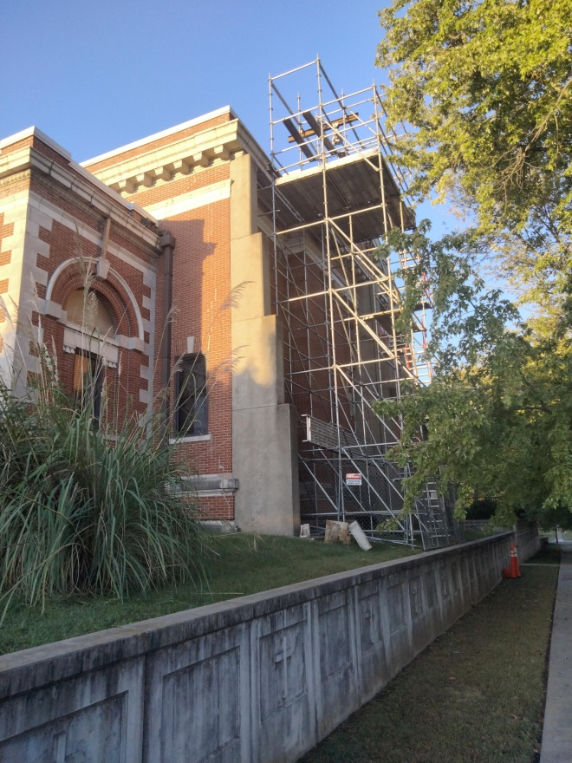

CORNICE WORK

Work on the cornice on the north side of the building continues at the church, which is now 112 years old. MTS Contracting Inc., North Kansas City, Mo., is the contractor.

PWC
OPERATION CHRISTMAS CHILD
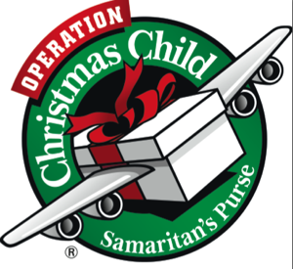
The stores will soon have their Christmas displays out and it's only October 1! It is also the time we began thinking about Operation Christmas Child as we have one month left to get our boxes together. Presbyterian Women have been supporting this Mission for Children across the world for many years. Operation Christmas Child (OCC) is a division of Samaritan’s Purse.
This year the boxes are due to the Church by the first week in November so that we may get them to the local distribution point. Help lists, colorful shoeboxes, and labels are available in the Narthex. (You may use your own cardboard or plastic shoeboxes.) Each box should be packed for a girl or a boy in age category 2-4; 5-9; 10-14. The box may be a child’s only gift – include fun things as well as school and hygiene items. (Ideas are on the help sheet).
Donations toward the $9/box shipping costs are welcome (checks should be made out to Samaritan’s Purse or, if giving via our church, indicate OCC in the payment line with your cash/check.) If you give your donation on line you may track your box (you will receive a special tracking label). For a lot of good information go to https://www.samaritanspurse.org/what-we-do/operation-christmas-child/
Let's make this our most generous year yet!

FELLOWSHIP TREATS
Oct. 3-Session Oct. 10 –Choir and Bell Choir Oct. 17-Circle 3 Oct. 24-Circle 4

OCTOBER BIRTHDAYS
10- Sally Azbill 11- Katie Hathaway 12- Bobbie Snyder 12-Marcus Butler
14- Barbara-Sue Rose 14- Melissa Gummert 15- Maria Traynham 18- Chuck Allen
19- Alice Williams 19- Bob Doby 19-Carolyn Anderson 22- “Candi” Hortence Humphrey
23-Emma Calloway 29- Judy Fulton 30-Chris Aus 30-Gustavo de la Cruz

OCTOBER ANNIVERSARY
15- Dan and Liz Williams

